Avon Township Supervisors Meeting – January 7, 2026
Tentative Agenda Packet

- Call to order – 7:00 PM; Avon Township Hall, Queens Road, Avon (MN). Also, available via Zoom (see footnote below)
- Pledge of Allegiance
- Roll Call
- Approval of agenda
- Approval of minutes – December 3, 2025
- Public Hearings – none scheduled
- Public Comments
- Planning Commission Report
  - Ritter certificate of compliance
  - Road plan
  - Planning commission members
  - Future agenda items
- Treasurer’s Report – Kelly Martini
  - Approval of the Treasurer’s Report & Cash Control Statement
  - Paid Leave Law – update?

- Claims & Payroll – Kelly Martini
  - Approval of claims, receipts & payroll

- Town Hall Report
  - Garbage disposal update

- Road Report & Roadwork Update
  - Winter Update – plowing, salt sand, plow accidents & insurance (file claim?), etc.
  - Complaint regarding plowing on Two Rivers Road and driver vendetta
  - Complaint regarding plowing in driveways on Cardinal Nest
  - Lower Spunk Lane plowing complaints & too much salt
  - Anderson driveway situation update
  - Inquiry regarding Lange’s plowing Peach Drive

- Scheduled Business
  - 2026 Meeting Schedule – Resolution 01-07-26-01 (yearly meetings); schedule Audit Board meeting (February 11?); schedule Organizational meeting (March 18?)
  - Elections – Resolution 01-07-26-02 (appointing judges); Resolution 01-07-26-03 (absentee ballot board)
  - Mayor’s conference survey – complete?

- Other Business (added at meeting)

- Reports
  - MAT Meeting – Martini

- Announcements
  - Signs (incl. 911) –
  - Construction Site Permits –
  - Special Assessment Searches – Scepaniak (18954 County Road 154; Avon, MN 56310-9720)
  - Feedlot permits –
  - County Hearings/Meeting –
  - Fire Department (November 2025 calls) – City: Medical 9, Fire/Other 3; Town: Medical 5; Fire/Other 0; Collegeville: Medical 1, Fire/Other 1; St. Wendel: Medical 0, Fire/Other 0; I-94, 2.
  - ME Govt & Commercial Expo – January 8th (Rogers, MN)
  - Gruber Christmas card received
  - MN LTAP Exchange newsletter received
  - Holdingford Fire Dept calendar received

- Old Business – Culvert mapping project & County app; 135th Avenue project with St. Wendel; Case to display old documents; Window treatments for Town Hall; Exterior sign for the Hall; Hiring HR / payroll company; Salt shed overhang/awning; Employee Handbook including earned sick time etc.; Pipeline Agreement; brush cutter rental for 2025; Records to historical society
- Signatures (as necessary)

- Announcement of next meeting: January 7, 2026 at 7:00 PM
- Other Upcoming Meetings/Events
  - Affidavits of Candidacy period – December 30, 2025 – January 13, 2026
  - Town Hall open to accept affidavits of candidacy – January 13, 2026; 1-5 PM
  - Fifth Monday – January 20; 6:30 PM
  - Planning Commission Meeting – January 28, 2026; 7 PM
  - Township Day at the Capitol – March 2, 2026
  - Town Hall open to accept absentee ballots – March 7, 2026; 10 AM – 12 PM
  - Public Accuracy Test – March 7, 2026; 10:15 AM
  - Town Hall open to accept absentee ballots – March 9, 2026; 1-5 PM
  - Township election (2-8 PM) & Annual Meeting (8:15 PM) – March 10, 2026
- Adjournment

DRAFT Minutes of the Meeting of the Avon Township Board of Supervisors
December 3, 2025
Avon Township Hall, 16881 Queens Road, Avon (MN)

Call to Order: Chad Klocker called the meeting of the Avon Township Supervisors to order at 7:00 P.M. in the Main Chamber of the Avon Township Hall. This meeting, like other Town meetings, was also available virtually via Zoom at https://us02web.zoom.us/j/8325486945, Passcode: AvonTown.

Pledge: The Pledge of Allegiance was recited.

Roll Call: Present – Craig Blonigen, Chad Klocker, Kelly Martini, Bryan Rassier, and Stephen Saupe. There was a quorum. Also present – Marion Gondringer, Casey Jansky, Andrew Wensmann, and Lori Yurczyk.

Approval of Agenda: A sheriff’s department report was added to the agenda. Blonigen moved to approve the agenda as amended. Rassier second. All in favor. Motion carried.

Minutes: Rassier moved to approve the minutes from the November 5, 2025 meeting as presented. Blonigen second. All in favor. Motion carried.

Public Hearings: none scheduled

Public Comments: There were no public comments.

Sheriff’s Department Report: A Deputy appeared at the meeting to update the Supervisors. The Deputy reported that there were 85 calls in July, 97 in August, 52 in September, 54 in October, and 59 in November. Most of the calls were traffic-related. There was one domestic assault in which officers from Cold Spring came to assist. There were a few burglaries and some kids ripping up the ditch on 182nd Street. Otherwise, there was nothing too out of the ordinary. An abandoned sailboat and trailer were observed in the road right-of-way on 360th; it was moved after about a week.

Planning Commission (PC) Report – presented by Andrew Wensmann

- Meyer Inquiry – Mr. Dan Meyers is considering splitting a parcel and inquired whether the Township had size requirements. He was advised that a parcel 10 acres or larger would typically be acceptable.
- Winkels Variance & Access Permit – The Planning Commission held a public hearing to consider a request by Brady & Maria Winkels, 15678 Parkwood Circle, for a variance to construct a garage 13 feet closer to the center of the road than is currently permitted. There were two concerns: water could potentially drain toward the property of the neighbor to the west, and if approved, the garage would require an Access Permit. The PC heard from several residents, considered the Findings of Facts, and recommends approval.
Blonigen moved to approve an access permit and that it must be inspected by a Township representative (Klocker) prior to installation to determine whether a culvert is required or not. Rassier second. All in favor. Motion carried.
Mr. Winkels, who was present at tonight’s meeting, said that the soil was gravel, but not clay. Blonigen moved to approve a variance for Mr. Brady Winkels, 15678 Parkwood Circle, to construct a garage 50 feet from the center-of-the-road on the condition that he installs a water mitigation system to catch water from the roof. Rassier second. Two in favor. One abstain (Klocker – because he has been contracted to do work on the project). The water mitigation system that Mr. Winkels agreed to install involved gutter downspouts running into a buried barrel with drilled holes to allow for the water to dissipate into the ground.
- Consideration to Reschedule the Monthly Meetings – It was suggested at the October to move the Supervisors meeting to the second Wednesday for bank-related reasons (i.e., provide time to allow checks clear, pay invoices in a timely manner). The PC discussed this idea and does not recommending switching the regular meeting date. However, the PC suggested that one way to avoid late fees is to alert creditors that the Township pays at 45 days (primarily to account for the meeting schedule). Blonigen moved to leave the Supervisors meeting on the first Wednesday of the month and to send a notice to suppliers that payment is net 45 days. Klocker second. All in favor. Motion carried. Martini will send out notices to suppliers.
- Assorted – The PC is working on reviewing the Road Plan, and suggests using electronic payments whenever possible.
Blonigen moved to approve the PC report. Rassier second. All in favor. Motion carried.

Treasurer’s Report: The Treasurer provided the Cash Control statement from November 1, 2025 to November 30, 2025 (appended below) and read the Treasurer’s report. There was a $30 overdraft fee charged to the Township; Martini forgot to move money prior to writing the check for the purchase of the new truck. She reported that the bank will waive the fee in this case. Blonigen inquired whether the Town has an auto transfer agreement set up at the bank. We received a tax settlement from the County – it got divvied up into the Town accounts. There are three separate escrow funds and are listed as having a zero balance. Though confusing it is done to avoid the funds showing up in the cash control statement and it appearing that the township has more money available than it does. It also reminds staff that the funds exist.
Blonigen moved to accept the Cash Control Statement and Treasurer’s Report with the $30 overdraft fee deducted. Rassier second. All in favor. Motion carried.

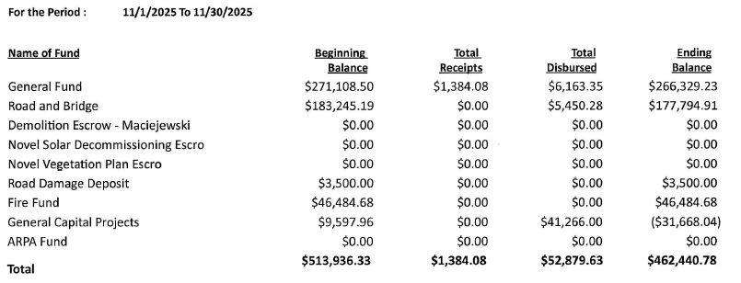

Claims, Receipts & Payroll: The claims (4943-4957) totaled $5,033.93 The disbursements (Appendix 1) and receipts (Appendix 2) registers are appended. Fine fees were received today but are not reflected on this statement. The payroll approved by the Supervisors was $2,373.52. Claim 4942 was for the new truck – it does not appear on the cash control statement. Checks 11565, 11566, 11567, 11568, and 11569 were voided.
Martini deducted the purchase of the new truck from Capital Projects fund, which now has a negative balance. Blonigen moved to transfer $40,000 from the General Fund to the Capital Projects Fund. Rassier second. All in favor. Motion carried.
Martini will file the ARPA fund paperwork. The ARPA Fund row of the statement will be removed at the end of the year. Central Hydraulics alerted the Township of a change to their charge policy. Martini reminded everyone to cash any outstanding checks by the end of the year.

Klocker and Jansky reported that James Gondringer (35538 Tower Road) and Glen Koshiol (36819 Pelican Lake Road) did not damage the township road when their new accesses were created. Blonigen moved to return the full damage deposits to Gondringer and Koshiol. Rassier second. All in favor. Motion carried.

Paid Leave – Town employees with an email address were sent the Minnesota Paid Leave notice and the flyer was posted at the Town Hall. The town will need to designate a paid leave administrator and set workplace policies. There are still many questions about how this program will work for the Township. Blonigen moved to authorize Martini to have the paid leave forms completed by Town employees. Klocker second. All in favor. Motion carried. Martini will follow up.

Martini reported that the Town now only needs to report taxes annually rather than quarterly.

Blonigen moved to accept the claims, receipts and payroll. Rassier second. All in favor. Motion carried.

Town Hall Report: The garbage disposal will be examined; it doesn’t appear to be working. Four windows in the hall need to be replaced. The furnace doesn’t appear to be running as much as it used to be, suggesting that insulating the Maintenance Shop may have helped conserve heat. The Avon Hills Lion’s did a fall cleaning on the Town Hall including the windows. Rassier moved to send a card to the Lion’s thanking them for their work. Blonigen second. All in favor. Motion carried. The Supervisors signed the card. There are some white streaks beneath some windows. There was a question about what sort of cleaner they used. The Clerk will follow up.

Road Report:

- Winter – the Red truck main cylinder is leaking. This truck needs to be replaced; it continues to break down. One concern is that if a decent truck is found between meetings, it will likely be bought before the Township has a meeting to approve the purchase. To avoid that problem, Rassier moved to authorize the purchase of another plowtruck for a maximum of $20,000 with trade-in including plow blade. Blonigen second. All in favor. Motion carried. Blonigen said that airport mechanics might be able to work on Town vehicles for cost.
Klocker suggested a part-time driver should be hired. The current drivers are Casey Jansky, Dillon Hedlund, Josh Raab, and Dwayne Massman. Blonigen moved to authorize Craig Doll as a part-time snowplow driver. Rassier second. All in favor. Motion carried.
Ms. RoseMary Anderson inquired why her drive had not been plowed as per agreement. She was told that plowing would have done too much damage since the ground was not yet frozen. It will be plowed as necessary as per township agreement. There were no complaints about plowing from Peach Drive.
- LRIP Grant – Blonigen said he submitted the LRIP grant for $676,648. This doesn’t include the cost of engineering or project management. The Town should find out in February or March whether we are awarded a grant or not.
- Truck Purchase & Sale – the Town has purchased a new truck. The old one will be sold to the City for $7,000 plus a year’s use of the compost facility. The Clerk will send an invoice to the City.
- Weed Report – The annual noxious weed control report was discussed and completed. Klocker signed the document and the Clerk will submit the report.
- Deer on Road – the Town was alerted to a deer on the roadway near 37081 Co Rd 9. It was removed by a resident.
- Lower Spunk Lane – a complaint was received regarding the plow dumping snow in front of a driveway near the end of the road. Klocker will follow up.

Blonigen moved to approve the Road Report. Rassier second. All in favor. Motion carried.

Business:
- TCHS Contract – Rassier moved to approve the contract with the TriCounty Humane Society. Blonigen second. All in favor. Motion carried. Klocker signed the contract. The Clerk will follow up and return the signed contract.
- SLFRF – Martini is handling the reporting. She said it was due in April.
- Stearns County Officers Association – There was a question of whether the association was worth the fee. Martini said that all townships are members and that the organization hosts speakers and informational sessions. The supervisors generally agreed that we will remain in the association.
- AED’s – Martini said that Collegeville Township has four AED’s. There are ongoing costs to host them.
Other Business: none
Reports:

- OAA – The City has signed the document and the City Administrator has sent it to the State for filing.
- Elections – the Township election is scheduled for March 10, 2026. The terms of Saupe and Klocker are up. Residents will elect a Clerk for a two-year term and a Supervisor for a three-year term. To be on the ballot, a candidate must file an affidavit of candidacy with the clerk. Affidavits are available from Dec 30, 2025 until Jan 13, 2026. The Town Hall will also be open on January 13 from 1-5 PM to file and accept affidavits.

Announcements:
- Signs (incl. 911) – a request for a 911 sign for Lumley, 37880 145th Avenue, was received. A sign will be purchased when the fee is received from the applicant.
- A Construction Site Permit was received for Lumley (37880 145th Ave; 24x108 greenhouse).
- Special Assessment Search were performed for Becker (36914 Pelican Lake Road); Hildreth (37313 185th Avenue); Opatz (37548 Co Rd 155); Angulski (19467 Saint Anna Drive); and Pierskalla Revocable Trust (37524 Co Rd 155).
- No Feedlot permits were received.
- There were no pertinent County Hearings/Meetings.
- Fire Department (October 2025 calls) – City: Medical 8, Fire/Other 0; Town: Medical 5; Fire/Other 0; Collegeville: Medical 2, Fire/Other 0; St. Wendel: Medical 0, Fire/Other 0; I-94, 0.
- A Central Landscaping brochure was received. They have salt/sand mixes available (320-252-1601; hermanr@centrallandscape.com).
- There was an issue with website – the map is not appearing. The web host has been alerted to the issue and he will fix.
- Need info? MAT video library (https://www.mntownships.org/mat-video-library).
- The truck title arrived. Martini put it in the Safety Deposit box at the bank.
- Belgrade Coop sent propane safety literature and the Broadcaster newsletter.
- Allied Blacktop sent a brochure – they do paving and parking lot repair. (www.alliedblacktopmn.com)
- A request for donations for the Avon Community Center was received. (www.avoncommunitycenter.com)

Old Business: Culvert mapping; 135th Avenue project with St. Wendel; Windows; Case to display old documents; Window treatments; Exterior sign for the Hall; hiring HR / payroll company; salt shed overhang/awning; CDL License changes; Employee Handbook, concrete sealing; Employee Handbook including earned sick time etc.; Pipeline Agreement.

Signatures / Documents / Treasurer: Documents were signed as necessary.

Announcement of Next Regular Supervisor Meeting: January 7, 2025; 7:00 PM.

Other Upcoming Meetings/Events: (available on Zoom at the URL above):
- Planning Commission Meeting – December 31, 2025; 7 PM
- MAT Conference – Dec 11-13, St. Cloud Civic Center (https://www.mntownships.org/annual-meeting). Martini will attend.
- Affidavits of Candidacy period – December 30, 2025 – January 13, 2026
- Town Hall open to accept affidavits of candidacy – January 13, 2026; 1-5 PM
- Township Day at the Capitol – March 2, 2026

Adjournment. Blonigen moved to adjourn the meeting at 8:36 PM. Rassier second. All in favor. Motion carried. Meeting adjourned.

Respectfully submitted, date: December 14, 2025
Stephen G. Saupe, Clerk

Supervisor Signatures: date: _____________________________
Appendix 1. Disbursement Register
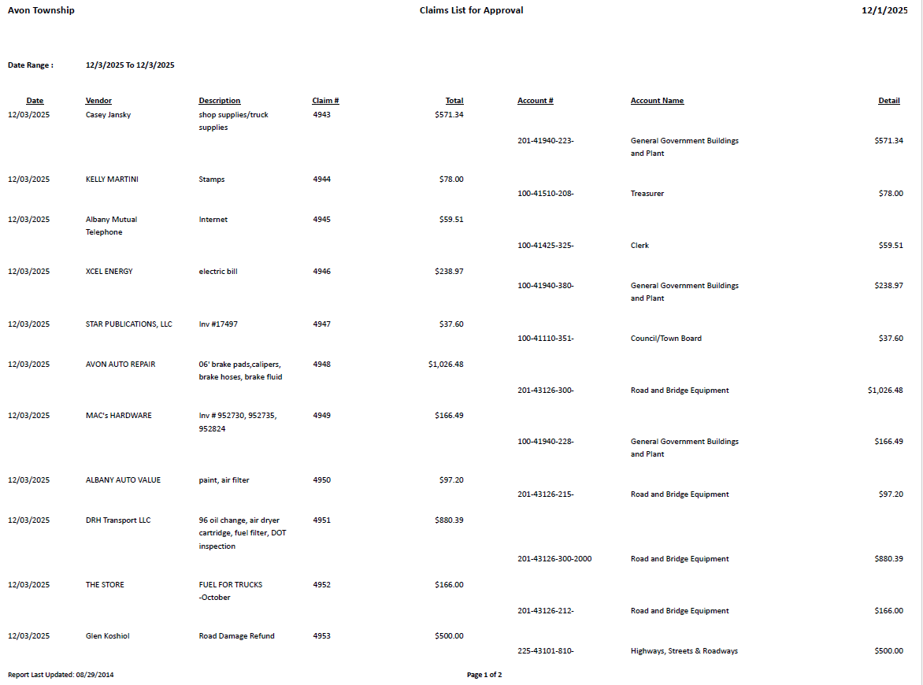

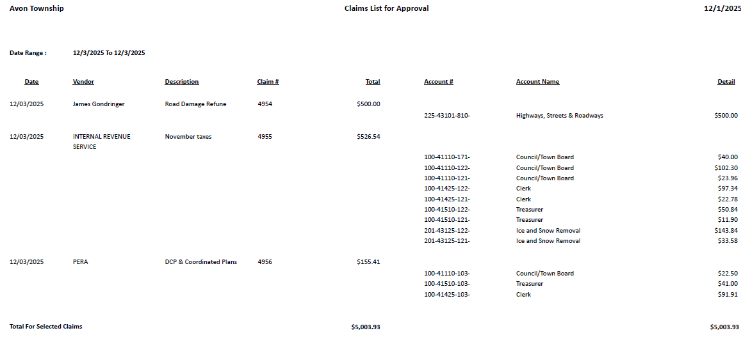

Appendix 2. Receipts Register

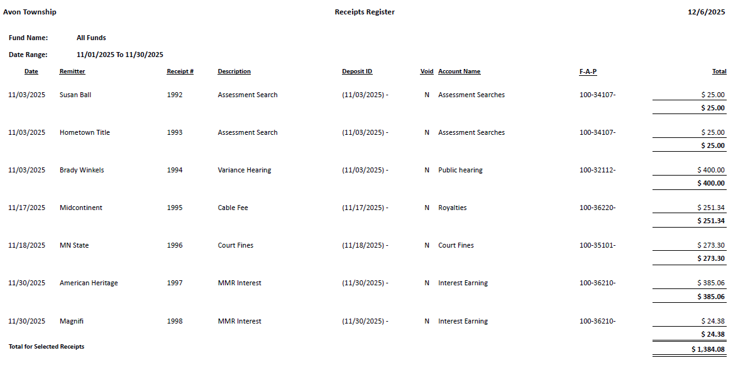

RESOLUTION 01-07-26-01
RESOLUTION POSTING THE 2026 REGULAR MEETING SCHEDULE OF THE AVON TOWNSHIP BOARD OF SUPERVISORS AND PLANNING COMMISSION

WHEREAS, the Avon Township Board of Supervisors passed Resolution 01-03-24-3: Updating the Regular Meeting Schedule; and

WHEREAS, the Avon Township Board of Supervisors regularly meets the first Wednesday of the month at 7:00 PM in the Avon Township Hall, 16881 Queens Road, Avon, MN; and

WHEREAS, the Avon Township Planning Commission regularly meets the last Wednesday of the month at 7:00 PM in the Avon Township Hall, 16881 Queens Road, Avon, MN; and

NOW, THEREFORE, BE IT RESOLVED, that the following is a summary of scheduled meetings for 2026.

Board of Supervisors | Jan 7 | Feb 4 | Mar 4 | Apr 1 | May 6 | Jun 3 | Jul 1 | Aug 5 | Sep 2 | Oct 7 | Nov 4 | Dec 2
Planning Commission | Jan 28 | Feb 25 | Mar 25 | Apr 29 | May 27 | Jun 24 | Jul 29 | Aug 26 | Sep 30 | Oct 28 | Nov 25 | Dec 30

Adopted this 7th day of January, 2026.

BY THE TOWN BOARD
Yes No Abstain

Supervisor _______________________________________ ___ ___ ___
Chad Klocker
Supervisor _______________________________________ ___ ___ ___
LeRoy Gondringer
Supervisor _______________________________________ ___ ___ ___
Bryan Rassier, Chair

Attest:

________________________________ _________________________
Marion Gondringer, Acting Town Clerk date

Avon Township
Resolution No. 01-07-26-02

RESOLUTION APPOINTING JUDGES FOR THE MARCH TOWNSHIP ELECTION

WHEREAS, Minnesota Statutes Section 203B.21, subd.2 require the town board, as the governing body of the town, to appoint election judges; and

WHEREAS, the election judges must meet the qualifications set out in Minnesota Statutes 204B.19;
NOW, THEREFORE LET BE IT RESOLVED: That the Town Board for the Town of Avon hereby appoints the following individuals to serve as election judges during the March Township election, provided they have received appropriate training and comply with all other applicable statutes and rules:

- Jackie Biniek
- Duane Fasen
- Marion Gondringer
- Kelly Martini (Head Judge)
- Sue Rushmeyer
- Colette Bresnahan
- Ben Byker
- Susan Chisholm
- Lisa Gilk
- Margie Lehner

BE IT FURTHER RESOLVED: That the Board of Supervisors of the Town of Avon hereby authorizes any election judge to be compensated as required by Minnesota Statutes.

Adopted by the Avon Township Board of Supervisors this 7th day, in the month of January in the year 2026.

BY THE TOWN BOARD
Yes No Abstain

Supervisor _______________________________________ ___ ___ ___
Craig Blonigen
Supervisor _______________________________________ ___ ___ ___
Chad Klocker
Supervisor _______________________________________ ___ ___ ___
Bryan Rassier

Attest:

________________________________ _________________________
Marion Gondringer, Deputy Clerk date

Avon Township
Resolution No. 01-07-26-03

RESOLUTION APPOINTING ABSENTEE BALLOT BOARD FOR THE ANNUAL MARCH ELECTION IN AVON TOWNSHIP

WHEREAS, Minnesota Statutes Section 203B.121, subd.1 requires the town board, as the governing body of the town, to appoint a ballot board to process all absentee ballots returned to the town clerk for the March Township Election; and

WHEREAS, the ballot board must consist of election judges trained in the handling of absentee ballots or staff trained as election judges; and

WHEREAS, even though only two members are required to meet whenever an absentee ballot needs to be processed, the ballot board must consist of at least the same number of members as the minimum number of required election judges for the town election;
NOW, THEREFORE LET BE IT RESOLVED: That the Town Board for the Town of Avon hereby appoints the following election judges to serve as the ballot board required to perform all duties required in the processing of absentee ballots required under Minnesota Statutes Section 203B.121 and all other applicable statures and rules:

- Jackie Biniek
- Duane Fasen
- Marion Gondringer
- Kelly Martini (Head Judge)
- Sue Rushmeyer
- Colette Bresnahan
- Ben Byker
- Susan Chisholm
- Lisa Gilk
- Margie Lehner

BE IT FURTHER RESOLVED: That the Board of Supervisors of the Town of Avon hereby authorizes any member of the ballot board to be compensated as required by Minnesota Statutes Section 203B.121, when said member performs any required duty of the ballot board.

Adopted by the Avon Township Board of Supervisors this 7th day, in the month of January in the year 2026.

BY THE TOWN BOARD
Yes No Abstain

Supervisor _______________________________________ ___ ___ ___
Craig Blonigen
Supervisor _______________________________________ ___ ___ ___
Chad Klocker, Chair
Supervisor _______________________________________ ___ ___ ___
Bryan Rassier

Attest:

________________________________ _________________________
Marion Gondringer, Deputy Clerk date

Avon Township
dates OKAY??
Notice of Elections, Annual Meeting, Board of Canvass Meeting, Absentee Ballots & Public Accuracy Tests

Notice is hereby given to qualified voters of Avon Township, County of Stearns, State of Minnesota, that the Annual Township Election will be held on Tuesday, March 10, 2026 from 2:00 PM until 8:00 PM. For the latter, to be elected are one Supervisor for a three-year term, and one Clerk for a two-year term.

Following the Township Election on March 10, the Annual Town Meeting will be held at 8:15 PM to conduct all necessary business prescribed by law. This will be followed by the Board of Canvass meeting at approximately 9:00 PM. In case of inclement weather, the Annual Meeting, Board of Canvass, and Township Election will be postponed one week, until the third Tuesday in March (Tuesday, March 17) at the same times. If inclement weather postpones these events on the third Tuesday, then the events will be held on Wednesday, March 18, 2026. Please listen to KASM radio (1150 AM) for any changes.

Absentee ballots for the Township election are available by mail, by contacting the Head Judge (320-493-9987), or at the Avon Town Hall before/after scheduled meetings. Absentee ballots can be returned by US Mail, dropped off at the Town Hall during open hours, or placed in the Drop Box outside the front entrance of the Town Hall. The Town Hall will be open on Saturday, March 7, 2026, from 10 AM – 12:00 PM, and Monday, March 9, 2026 from 1-5 PM to accept absentee ballots and for absentee voting.

The Public Accuracy Tests of electronic equipment for the Annual Township Election, will be held Saturday, March 7, 2026 at 10:00 AM.

The Qualification / Organization Meeting will take place on March 7, 2026 at 7:00 PM.

All of the above listed events/meetings occur in the Avon Township Hall, 16881 Queens Road, Avon, MN. The Avon Township Hall is handicap-accessible. The public is invited to all.

Stephen Saupe, Clerk
Email: clerk@avontownship.org
Website: www://avontownship.org

Published in the Enterprise February 18 & February 25, 2026.

