# Access Permit Application

**Purpose**: To provide safe access to a landowner’s property and Township roads, and to ensure all building sites in the township have 911 address signs.

1. **Property Owner’s Name**: __________________________________________________________________
2. **Application Date:** ________________________________________________________________________
3. **Phone**: ___________________________________ **eMail**: ______________________________________
4. **Address of Property**: _____________________________________________________________________
5. **Mailing Address** (if different): ______________________________________________________________
6. **Parcel Number**: __________________________ **Township** 125 **Range** 30 **Section** ________
7. **Public Road Accessed**: ____________________________________________
8. **Legal Description** (*or append*):
9. **Contractor Name**: _________________________________________
10. **Access Dimensions** (*drawing must be attached and is part of the permit application*).

**Agreement**: As homeowner, I understand it is my responsibility to read and understand the requirements of this application and Township Access policies and state that all information is true and correct to the best of my knowledge. I further agree that all work performed will be in accordance with approved plans, specifications and conditions, and will abide by all of the ordinances of Stearns County and Avon Township, regarding actions taken pursuant to this application. Any plans submitted herewith shall become part of the permit application. This application shall not be considered a complete application until the proposed access has been staked by the applicant. If work has not begun within a year, the permit is void. It is the responsibility of the applicant to obtain any other necessary permits from any other regulatory agencies or government bodies. Signature of this application authorizes the Avon Township Officials to enter upon the property to perform needed inspections. Entry may be without prior notice. Failure to comply with the Avon Township Access Policy will result in the forfeit of the damage deposit.

____________________________________________ _______________________________

Signature of Property Owner Date

**Township Approval**: File Number: ______________ This access permit **IS / IS NOT** (*circle one*) approved.

Permit Conditions: ____________________________________________________________

___________________________________________________________________________

Name (print): ________________________________________________________________

Signature: _____________________________________ Date: _______________________

Avon Township Board of Supervisors, Chair

Permit Expiration Date: ____________________ Photo Taken: ___________________

**Fees Collected:** Non-Refundable permit fee: ______ Damage deposit: $500 (*This is refundable for a period of two years from permit date, assuming no damage to the public roadway. Submit Damage Deposit Request form to Clerk when the work is complete to request return of the deposit)*

**Access Drawing/Dimensions**

A diagram showing the proposed access and dimensions must accompany the permit. The form below may be used, or the applicant may append a separate drawing, map, survey or other showing the access with dimensions.

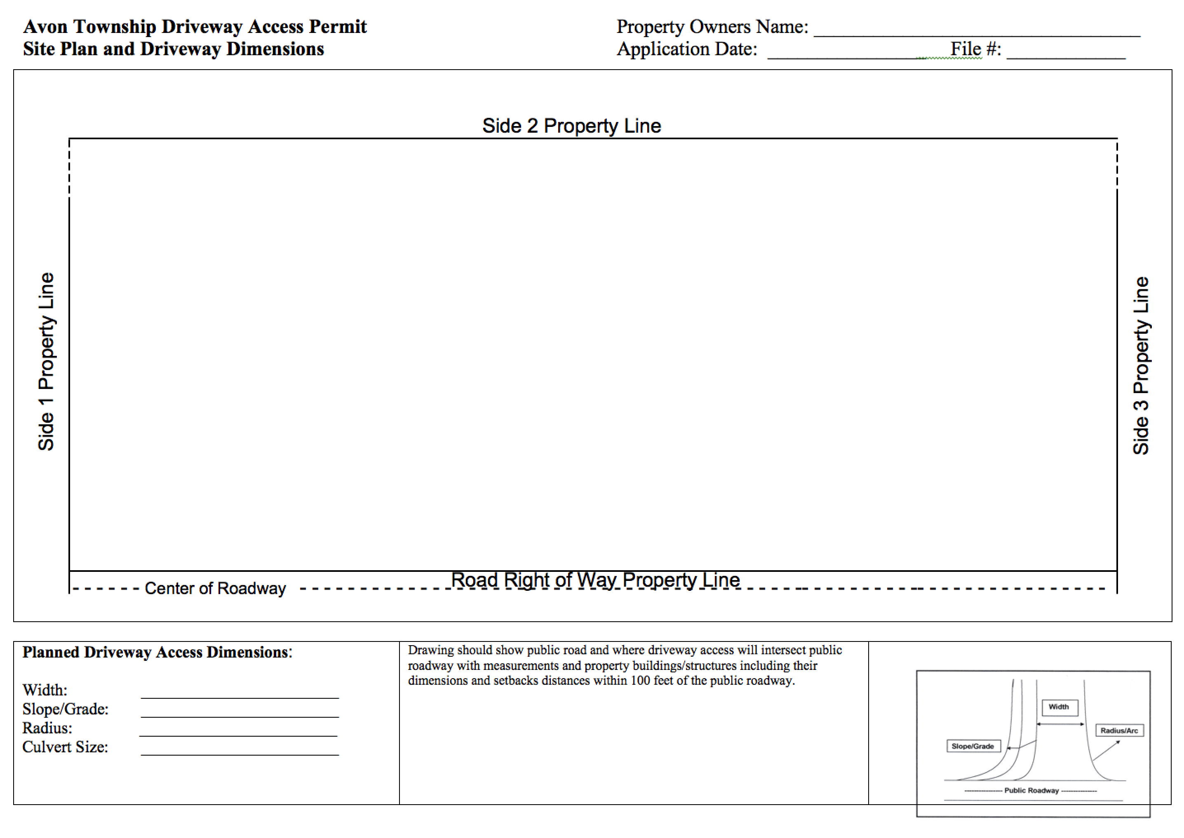

**Avon Township Access Permits**

**General:** Any resident who plans to move, change the physical dimensions, or slopes of an existing access (*including driveways and field approaches*), or adding a new access to his/her property in the Township road right-of-way requires an Avon Township Access Permit. Changing the surface material does not require an Access Permit. Access permits are required to ensure that Township roads are not damaged and that there is no public safety hazard created by the access. The permit costs $50.00. There is a $500.00 damage deposit that is collected when the permit is issued; it is refunded if no damage is done to the Town road during construction and all standards have been met.

**Standards** – *Accesses in Avon Township should meet the following standards (Resolution 01-06-21):*

1. All accesses shall be aligned to be straight and perpendicular to the centerline of the road within the limits of the Township right-of-way.
2. All accesses will be aligned with street or entrances on the opposing side of the roadway if possible.
3. Avon Township will determine if culverts and aprons are required, and the size/length that is required.
4. Culverts will be a minimum of 15 inches in diameter and made of steel or DOT-approved double walled plastic.
5. Aprons will accompany culverts and also be made of steel or DOT-approved plastic.
6. It is not permitted to remove the short heel that extends from the Township road into the driveway or access without approval by the Township Road Supervisor.
7. Separation distance from other accesses is at the discretion of Avon Township. Generally, only one access per 40 acres or smaller parcel is granted unless the resident can show a specific need for the additional access. All new accesses should be a minimum of 125 feet from any other access or intersection.
8. Accesses will conform to the standards of Stearns County (Highway Department Access and Right of Way Width Guidelines) including:

1. Residential access surfacing width shall be a minimum of 16 feet and/or a maximum of 24 feet;
2. Commercial and industrial access surfacing shall be 30 feet in width;
3. Field accesses shall be a minimum of 16 feet in width;
4. Entrance/access widths of up to a maximum of 40 feet will be considered under special circumstances (such as high volumes of semi-tractor trailers, field accesses, narrow adjacent roadways, etc.); and
5. Street accesses shall be a minimum of 30 feet in width and shall be paved within the limits of the Township right-of-way or graded to drain away from the Township roadway.
6. Only breakaway mailbox posts are permitted.
7. An access must be set back from a side lot at least 10 feet, unless there are special circumstances (*i.e.,* shared accesses, limited space, obstructions) that will be examined on a case-by-case basis. The Supervisors, at their discretion, can approve requests for an exemption from this rule.

**Non-Conforming Requests** – Avon Township Board of Supervisors make the final decision about any Access Permit that is issued in the Township. If a requested access is more than 40 feet wide, it requires a variance hearing for approval. A request for an access between 24 – 40 feet will be reviewed by the Planning Commission, which will forward a recommendation to the Supervisors for consideration for approval. Any deviation from these policies must first be approved by the Avon Township Road Supervisor, or a designee, prior to construction. Failure to comply with the Avon Township Access Permit policies will result in a forfeiture of the damage deposit.

**Access Inspector** – The Avon Township Road Supervisor or designee is responsible for documenting the road condition before and after the work, determining if a culvert and aprons are required, and whether or not the completed work meets Township specifications.

# Avon Township

16881 Queens Road; Avon MN 56310

# Request for Return of Road Access Damage Deposit

# Upon completion of access construction, the property owner may request the return of the Damage Deposit. An inspection will take place by Township personnel to determine if there has been any damage to the Township roadway. After this inspection, the request will be brought to the Supervisors’ Meeting for approval or denial. Request must be made within two years of the original permit date.

1. **Property Owner’s Name**: ________________________________________________________
2. **Phone**: _________________________ **email**: _______________________________________
3. **Address of Property**: ____________________________________________________________
4. **Mailing Address** (*if different*): _____________________________________________________
5. **Parcel Number**: ____________________ **Township** 125 **Range** 30 **Section** ______
6. **Date of Original Permit Approval**: ­­­­­­­­­­­­­­__________________
7. **Please explain the action that was taken concerning this access**. (*i.e.,* new construction, modification, alteration in size, change in surface material, culvert addition/replacement)

**Signature of Property Owner** **Date**

***Area below for use by the Township***

**Township Approval**:

Inspection date: ______________________________ Photo retaken: __________________

Notes from Inspection (i.e., work done without damage, describe damage)

Access damage deposit return: **IS APPROVED** / **IS NOT APPROVED** (*circle one*)

Amount approved for refund: $_____________________________________

**Signature** (*print*): _________________________________________________________________________

**Name** (*print*): _______________________________________________ **Date**: _______________________

Avon Township Board of Supervisors, Chair